

MATHEMATICS DEPARTMENT |  | 
Course: ATMAA
Topic Title: Skills Test 6
Student Name:_____________________________________ | Date: __________2016
Special Instructions: No Calculators | Time Allowed: 15 mins
 | Marks: / 10
Question 1
Write down the first four terms of the sequence if a₁ = 1 and a_{n+1} = 2a_{n} + 4.

A 0, 4, 12, 28 B 1, 4, 10, 18 C 1, 4, 12, 28

D 1, 6, 16, 36 E 6, 16, 34, 72

Question 2
A sequence is defined by t_{n+1} = at_{n} + 3 where t₁ = 8. For what value of a will the sequence have a long-term steady state solution of 6?

A $a=0.4$ B $a=0.5$ C $a=-0$

D $a=0.6$ E $a=-0.6$

Question 3
A recurrence relation generates the arithmetic sequence 5, 9, 13, 17, ... Find a rule for the nth term of the sequence.

A $t_{n}=n+4$ B $t_{n}=4n-3$ C $t_{n}=4n+1$

D $t_{n}=4n+5$ E $t_{n}=5n+4$

Question 4
Given the recurrence relation t_{n+1} = 2t_{n} + 3 and t₃ = 25, find t₆.

A 109 B 206 C 221

D 315 E 445

Question 5
Which of these is the explanatory variable and which is the response variable?
Consider ‘plant yield’ and ‘amount of fertiliser’.

A | Response variable: plant yield  Explanatory variable: amount of fertiliser
B | Response variable: amount of fertiliser  Explanatory variable: plant yield
C | Both are response variables.
D | Both are explanatory variables.
E | They are neither response variables nor explanatory variables

Question 6
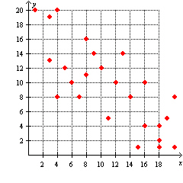
What kind of a relationship could be concluded between the x and y variables from the scatter plot below?
A Strong positive
B Strong negative
C Moderate positive
D Moderate negative
E No relationship

Question 7
How would you describe the distribution of the following data?
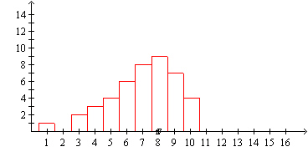
A Positively skewed
B Negatively skewed
C Symmetric
D Bimodal
E There is an outlier

Question 8
The following is a graph of a road map. Distances are in kilometres.
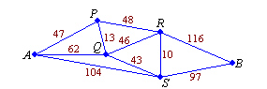
Find the shortest path from A to B.

A A-S-B
B A-P-R-B
C A-Q-S-B
D A-P-Q-S-B
E A-P-Q-R-S-B
Question 9
Which one of the following graphs is Eulerian?

A  B  C

D  E 

Question 10
Redraw this graph as a planar graph:

